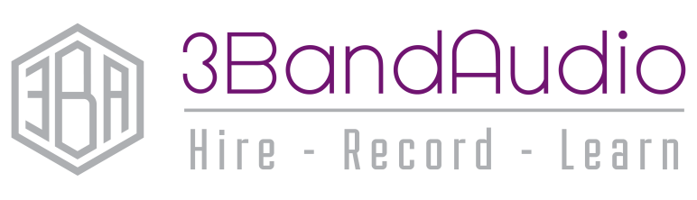
TECHNICAL REQUIREMENT FORM
Event: | Date:

Act name:
Type of act:
How many performers:
Technical Requirements:

Type of microphones needed:
(Wireless/Wired/Ambient/Headset…etc)
How many of each needed:
Use of backing music or tracks? (Yes/No)
If yes, what device are your tracks on? (Tablet/Phone/Laptop/USB)
Would you want to cue your own music on stage? Or have our engineer cue them for you?
Are there live instruments? (Yes/No)
If yes, what instruments?
(Guitar/Drums/Keyboard…etc)
Do you supply your own instruments? (Yes/No)
Do you supply your own instrument amplification? (Yes/No)
Act Details:
Any Questions/Special Requirements:
3BandAudio, 33 Heybeck Lane, Woodkirk, Dewsbury, WF12 7QT
info@3bandaudio.com / 07814 785977

